SOFTWARE ENGINEERING PRACTICAL DAY-1 - CSA1045

Q1. Online Voting System – Use Case Diagram

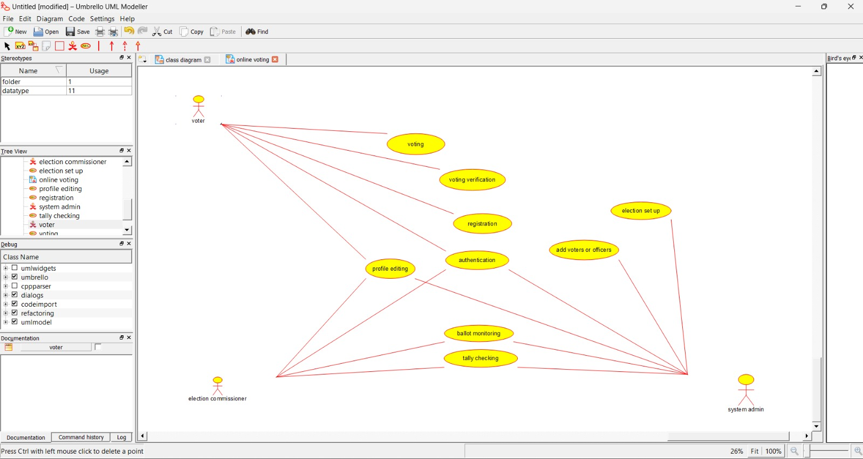

Q2. Library Management System – Use Case Diagram

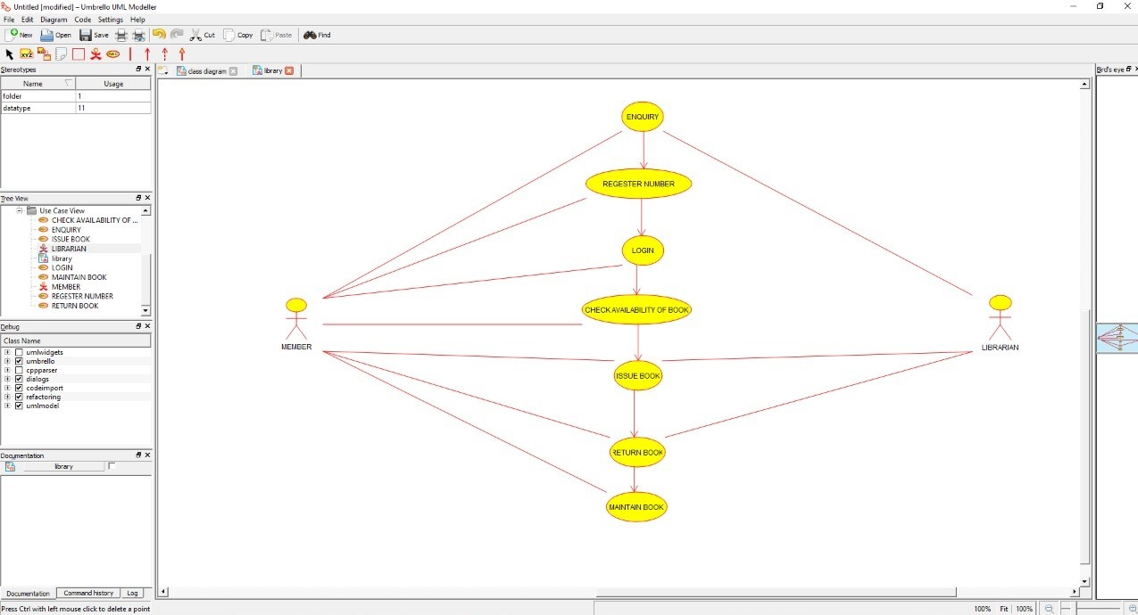

Q3. Division – Raptor

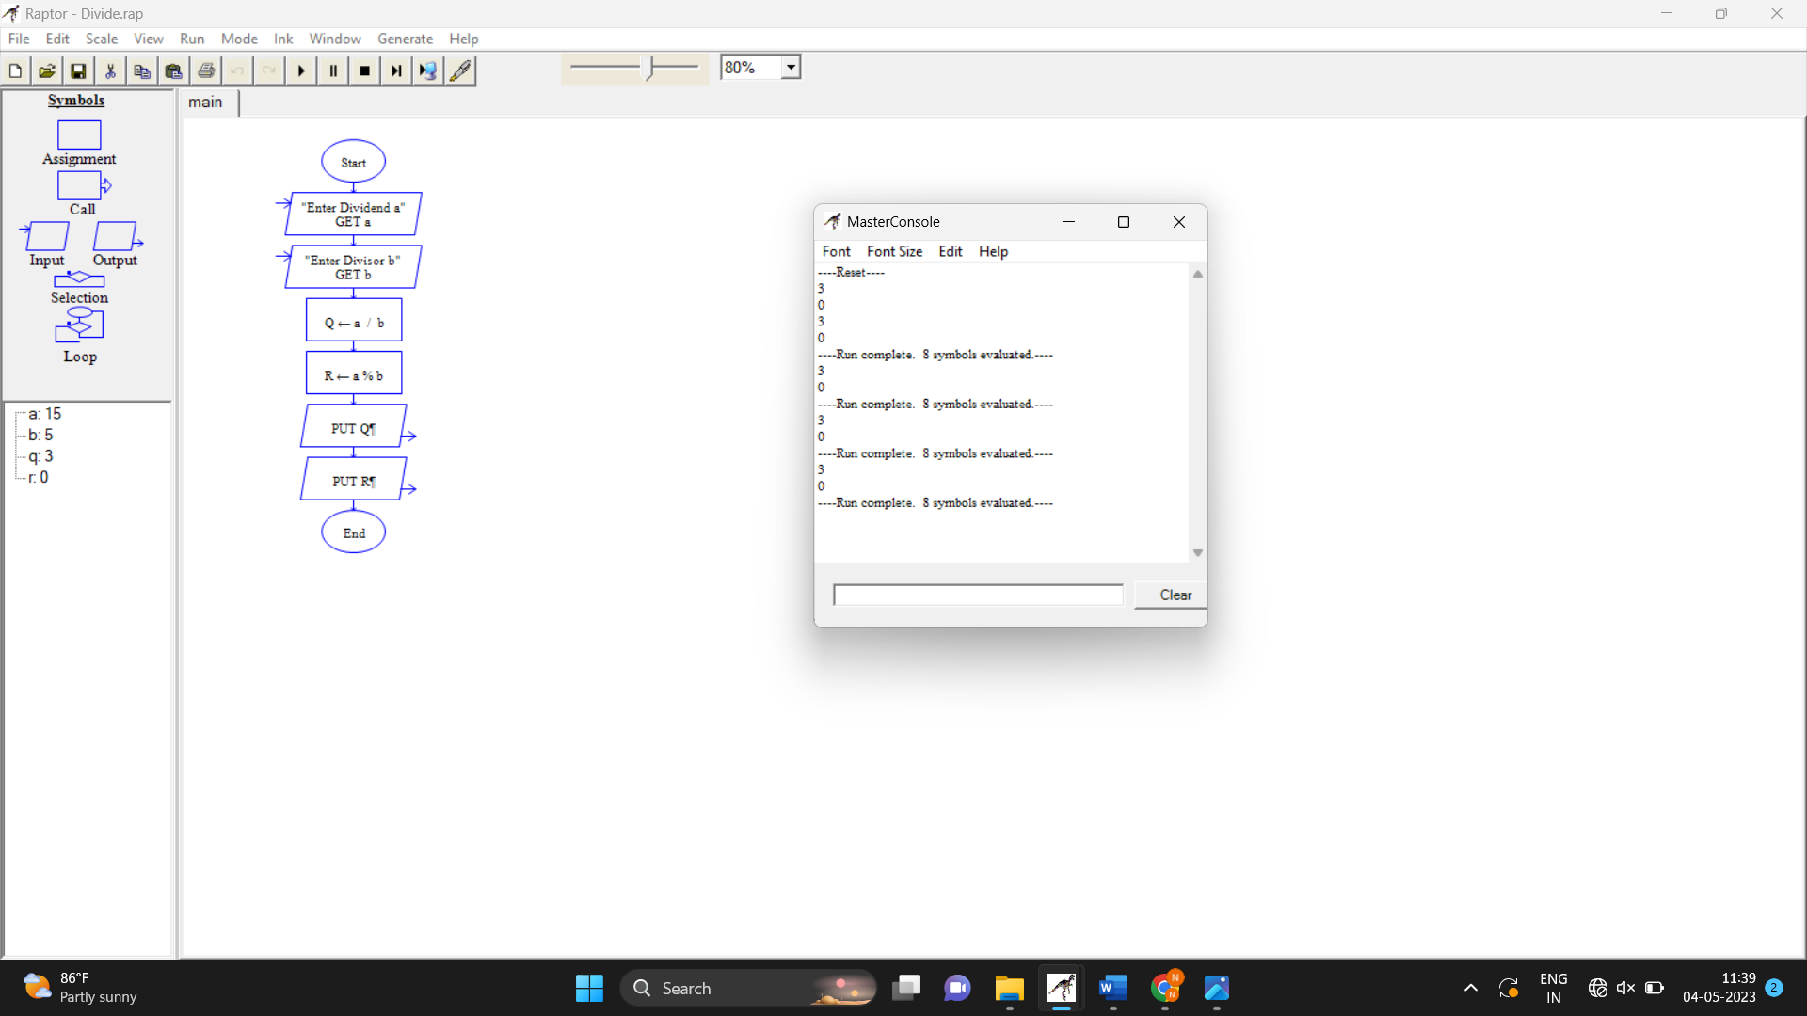

Q4. Shopping Cart System – Use Case Diagram

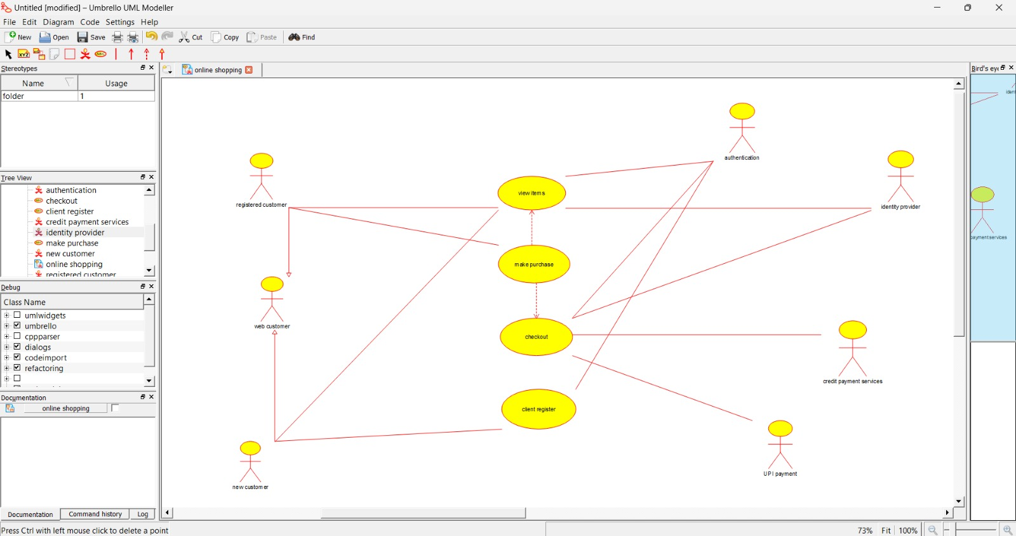

Q5. Railway Reservation System – Use Case Diagram

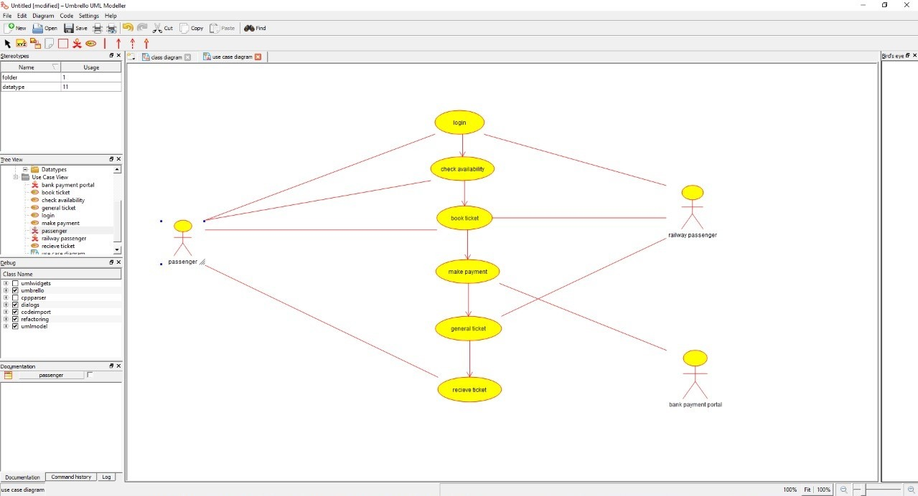

Q6. Hospital Management System – Use Case Diagram

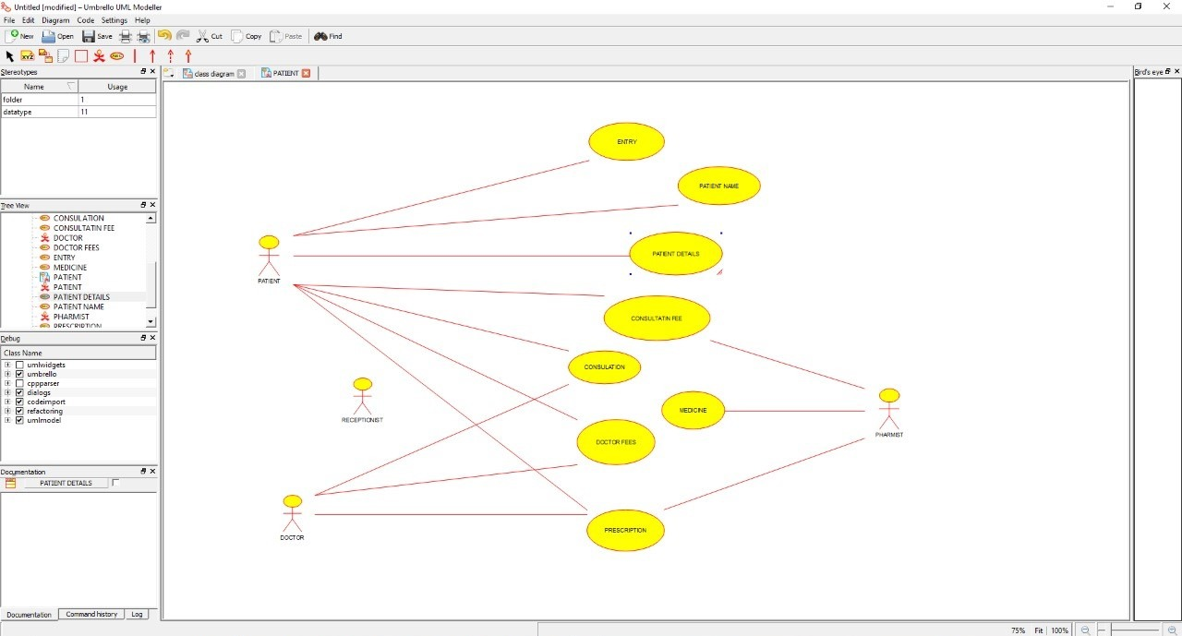

Q7. ATM System – Use Case Diagram

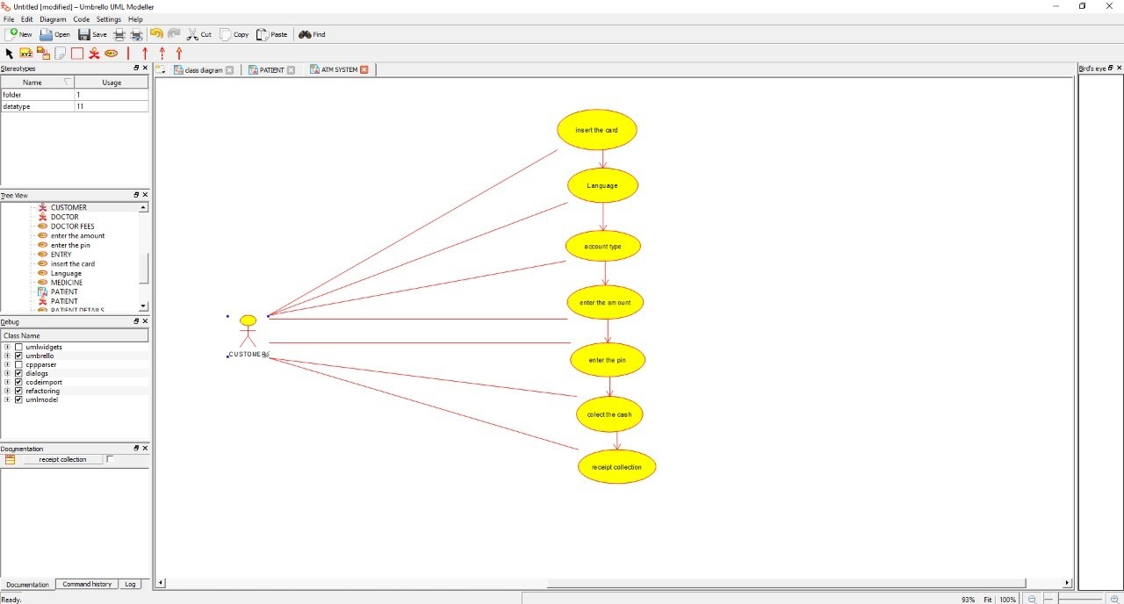

Q8. Online College Management System – Use Case Diagram

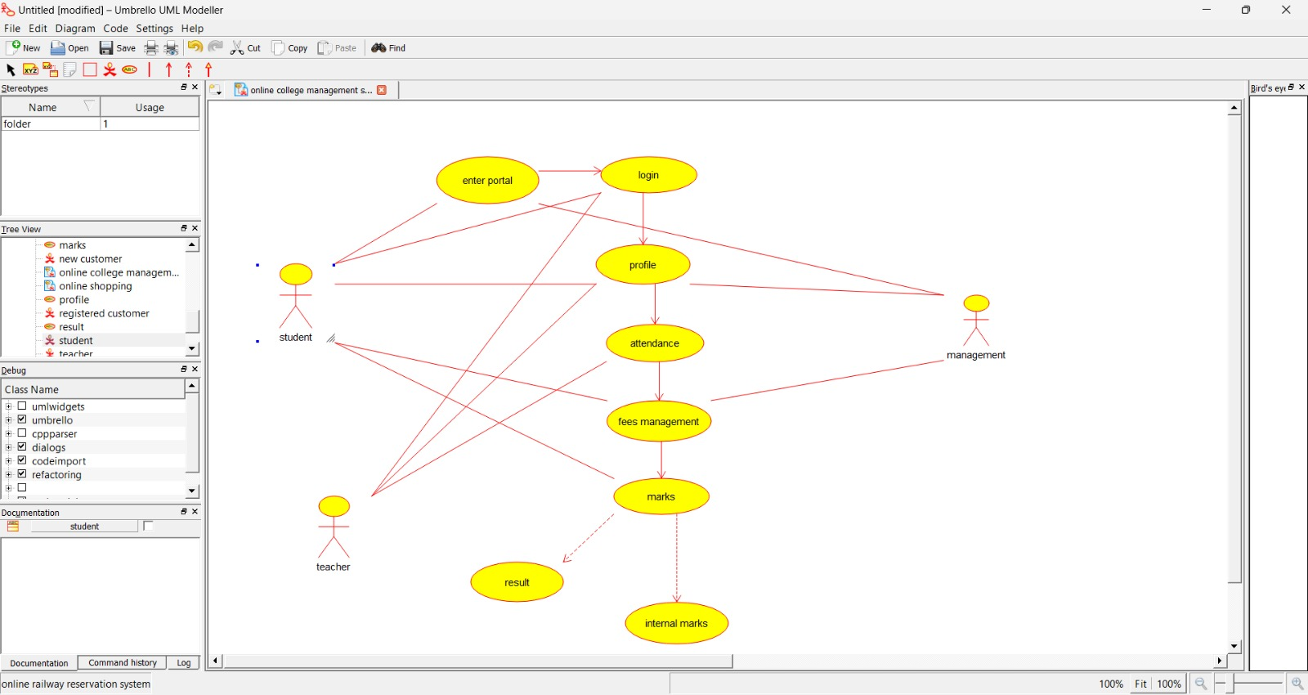

Q9. Online Airline Reservation System – Use Case Diagram

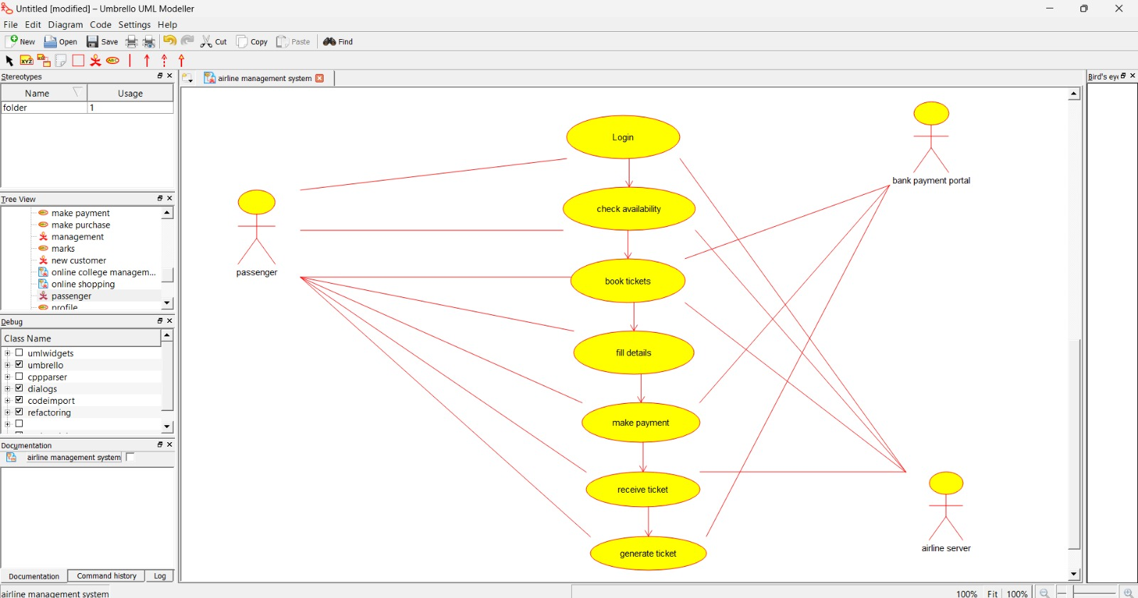

Q10. Online Airline Reservation System – Class Diagram

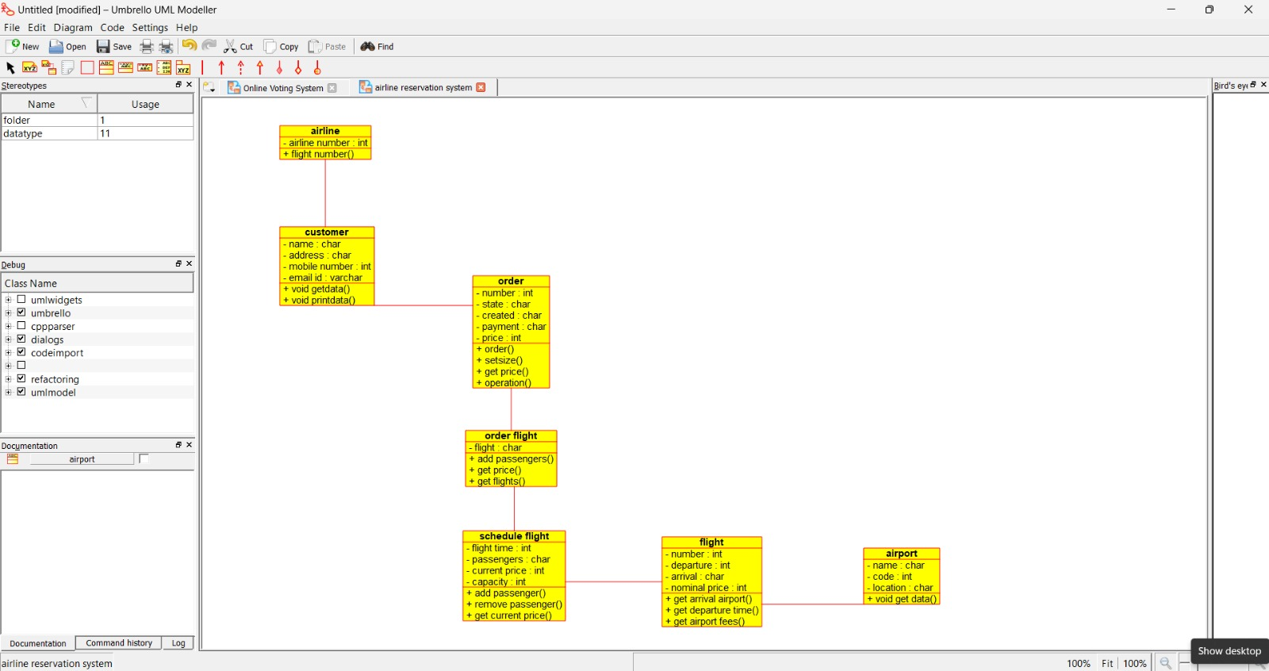

Q11. Online Voting System – Class Diagram

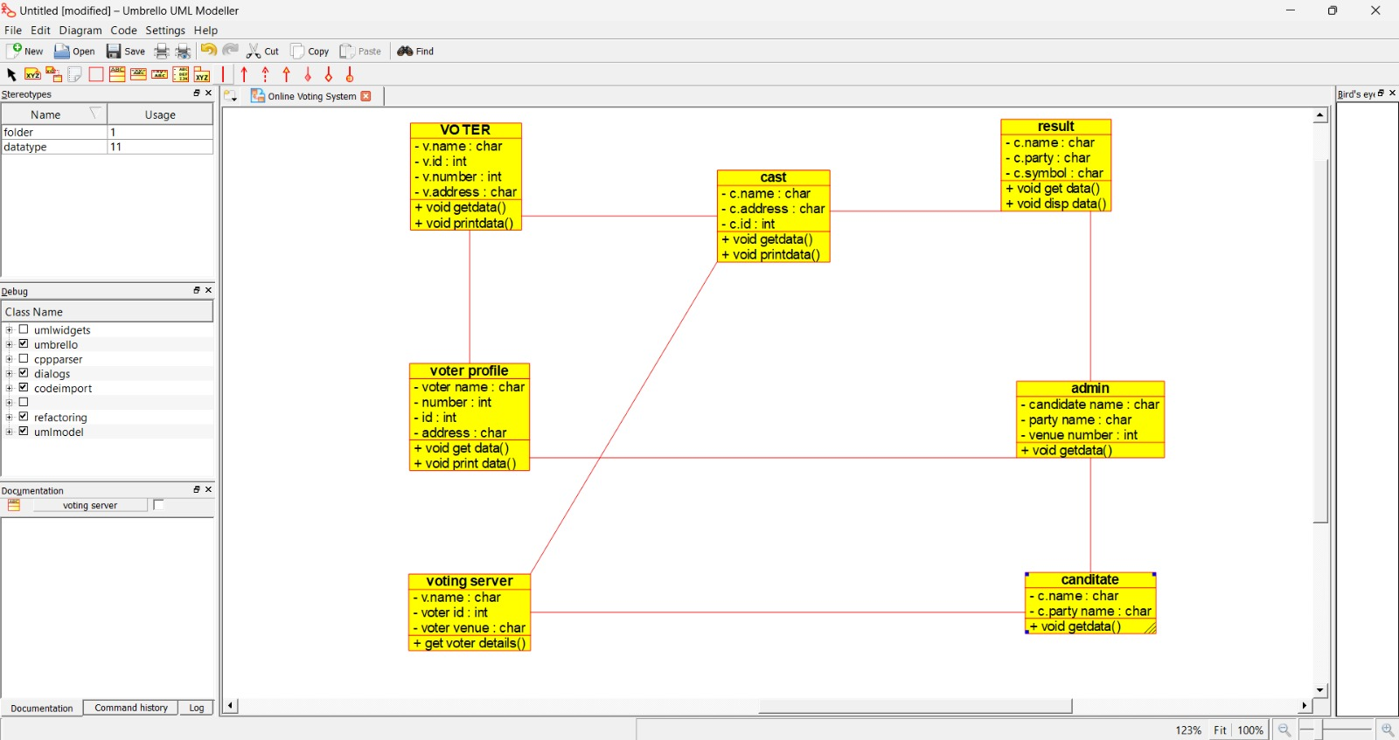

Q12. Library Management System – Class Diagram

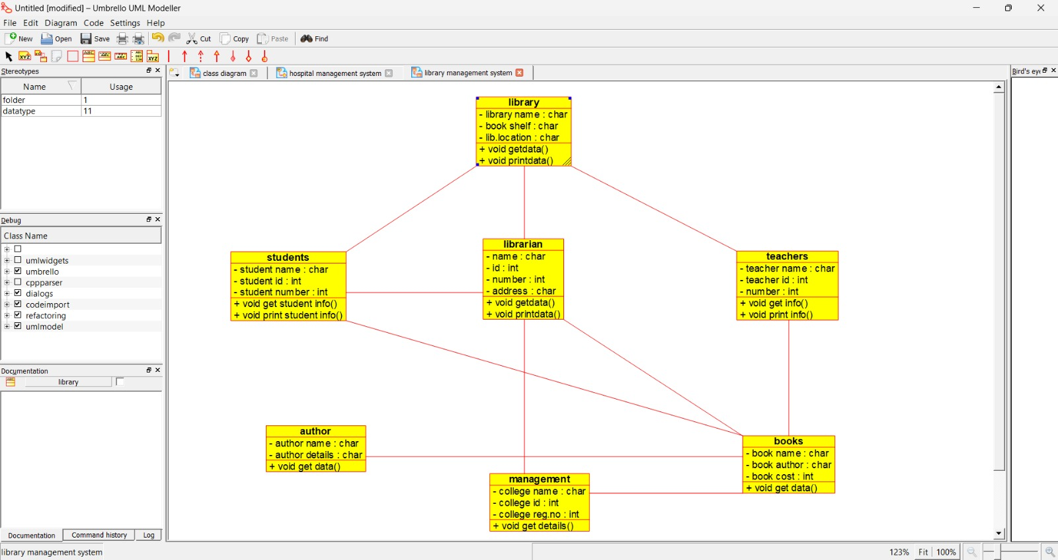

Q13. Online Voting System – Activity Diagram

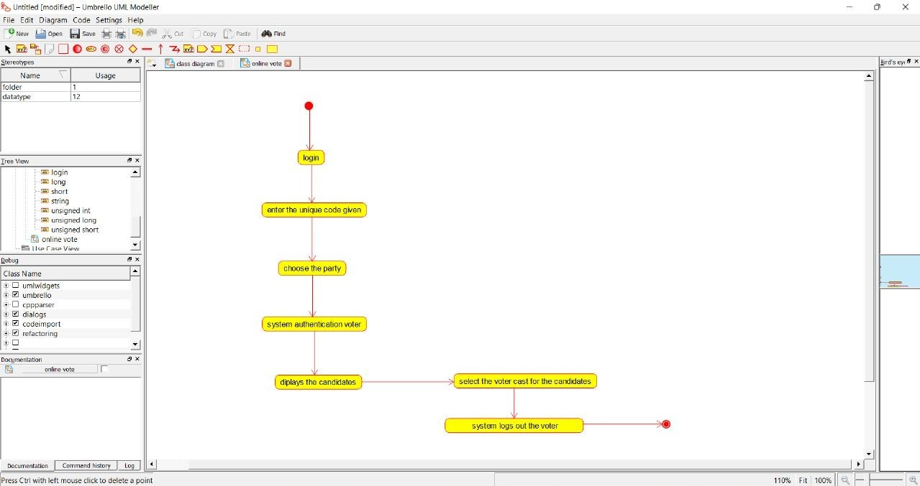

Q14. Library Management System – Activity Diagram

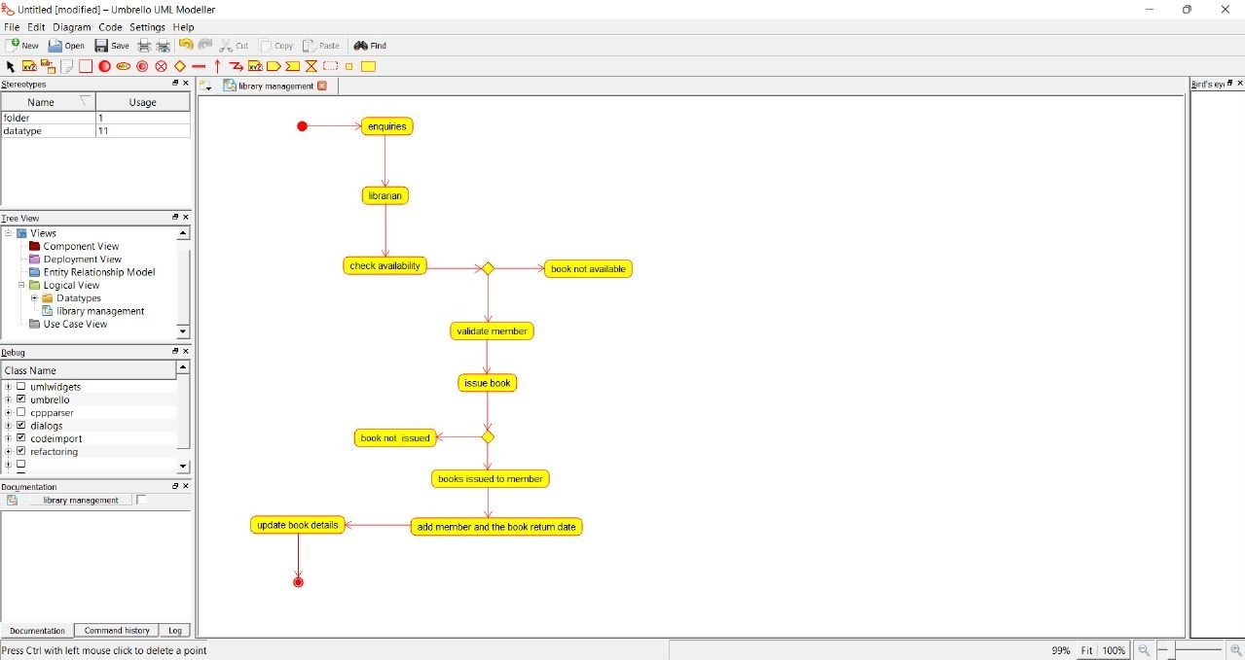

Q15. Online Shopping System – Activity Diagram

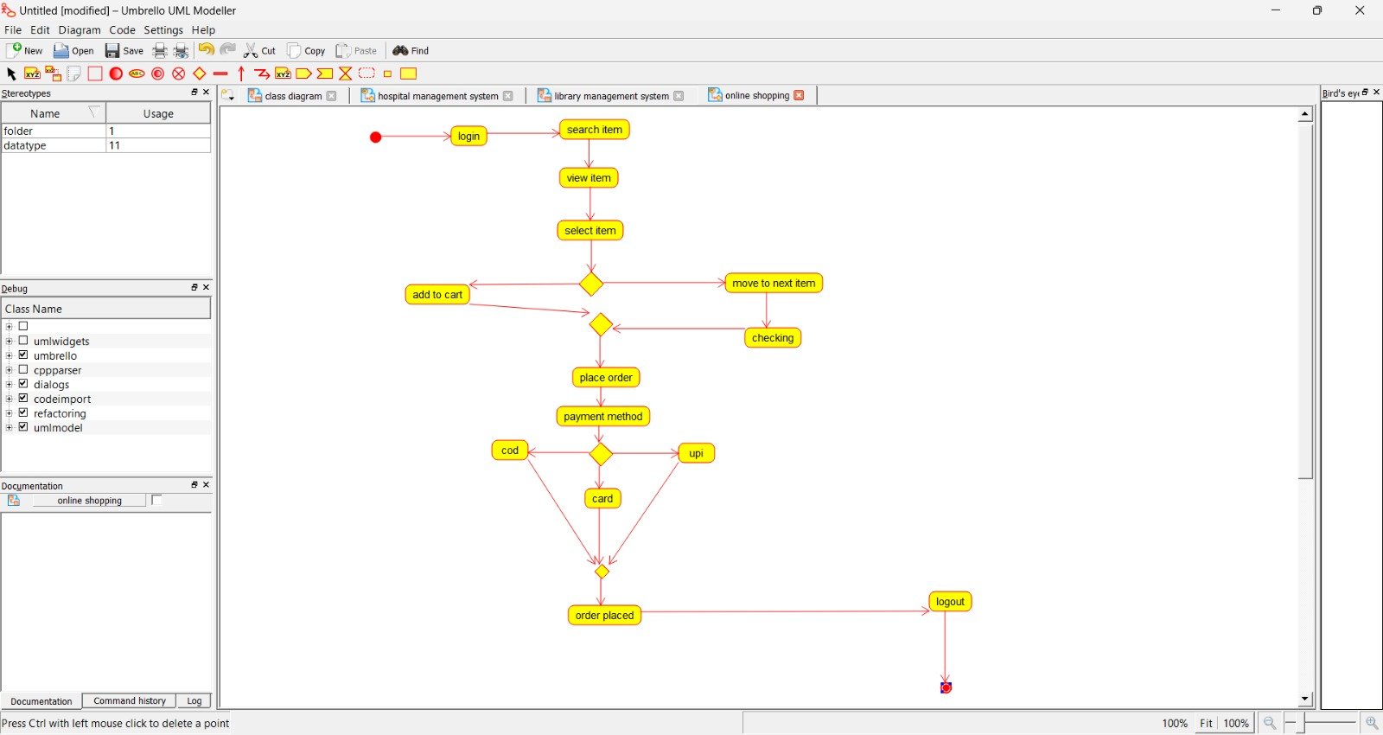

Q16. Online Railway Reservation System – Activity Diagram

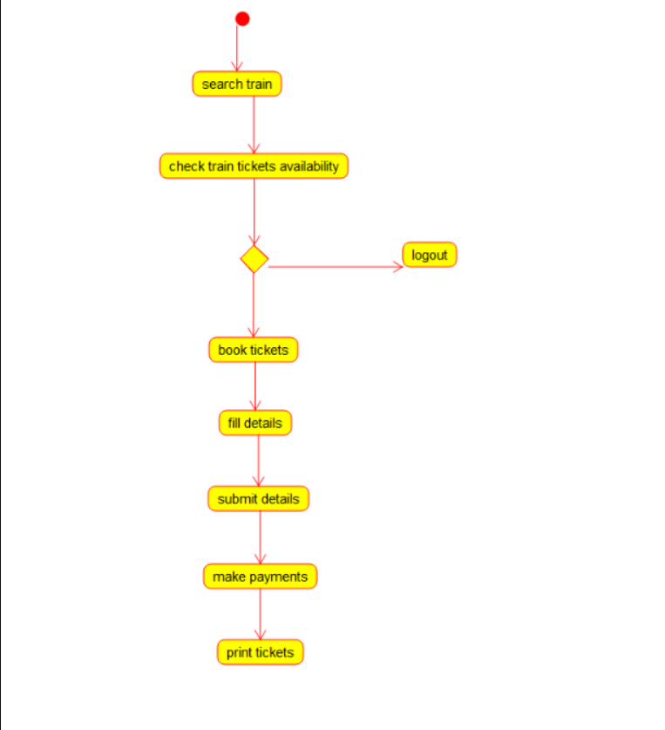

Q17. Hospital Management System – Activity Diagram

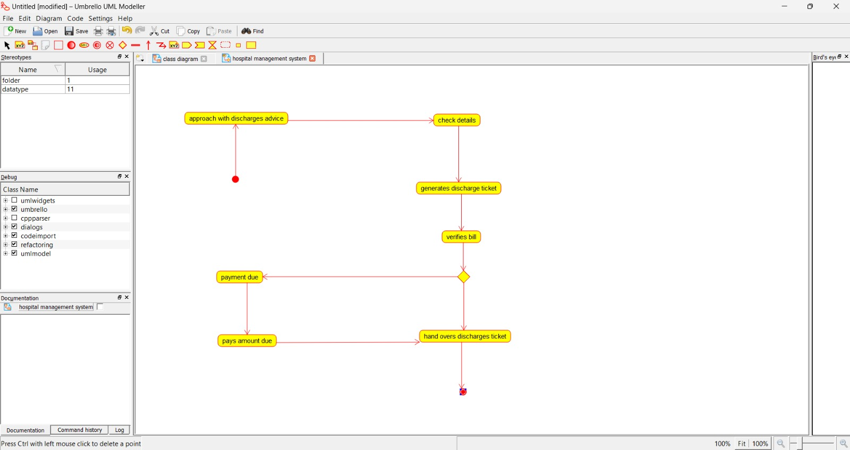

Q18. Palindrome – Raptor

